FEB 9, 2026
Source file: “asm1.s”
Test file: “test_01_all.s”
LA instruction:
Line 9: la $t1, math
$t1 = &math = 0x10010090

- lui $1, 0x00001001 (0x3c011001)
- ori $9, $1, 0x00001001 (0x34290090)
Data:
Entire String: “ERROR”
Substring length 4: “ERRO” = 0x4552524F
Adress in memory: 0x10010018 (alligned)
Word: 0x10010018 contains 0x4f525245

Discussion:
Screenshot of Memory address
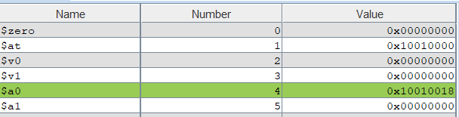
Screenshot of la instruction
This assignment gave me better understanding of how instructions are executed in ASM. Being the first language that is not object orientated, the thinking approach to implementing some of the tasks was quite different from how I would have done them in a higher level language like Java.
Debugging was a huge pain, especially when a typo caused data to be loaded into the wrong register ($1 instead of $s1, or $s1 instead of $t1).
There were a lot of copy and pasting code. I found myself copy and pasting most of the print syscall and then change the label in la. It was also a hassle to format strings, especially printing new line after a syscall 1 (I guess it started to make sense why most high level languges have print and println).
I didn’t know how to implement loops, so I found myself rewriting a lot of the same logic over and over again. I am looking forward to learning loops (as well as making my own functions, I have conditioned myself to make new functions really often, which made this assignment an interesting twist)

